**PSG COLLEGE OF TECHNOLOGY**

**DEPARTMENT OF APPLIED MATHEMATICS AND COMPUTATIONAL SCIENCES**

**15XW68 – DISTRIBUTED ENTERPRISE COMPUTING LAB**

**VI SEM – M.SC SOFTWARE SYSTEMS – JDBC and SERVELETS WORKSHEET**

## What is JDBC Driver? JDBC Driver Types. Which Driver should be used? When?

1. In this lab, you will create one web application consisting of two Servlets:

|  |  |
| --- | --- |
|  | i. A webpage must allow user to login and verify the entered credentials by obtaining the service from a Servlet, which will return a webpage that welcomes the particular user.  C:\Documents and Settings\cmc\Desktop\index.jpg |
|  | ii. The other Servlet will process user input (generated by the form page which you must create) and create/maintain a database, which it will display as a webpage as a result of processing the form. |

As an example for the second servlet Phonebook entry can be implemented as shown below,

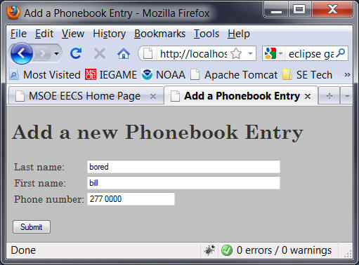

When the form is submitted, your form webpage should invoke your second servlet, which should append the information entered into the database. The servlet should then generate a response listing all of the form data that has been submitted to that point.

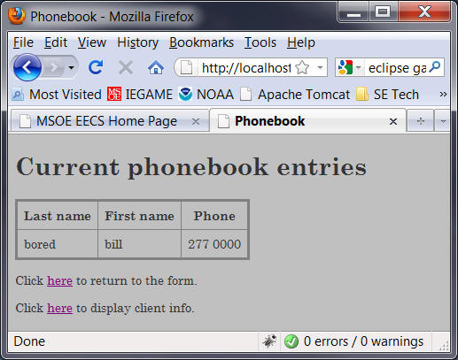

(**Note:** Business logic must be implemented using objects. Use separate java class to implement business logic.)